Assignment 4

Nikitha Chigurupati

11/1/2022

#Importing the Dataset  
Pharma <- read.csv("C:/Users/Nikitha/Downloads/Pharmaceuticals.csv")  
summary(Pharma)

## Symbol Name Market_Cap Beta   
## Length:21 Length:21 Min. : 0.41 Min. :0.1800   
## Class :character Class :character 1st Qu.: 6.30 1st Qu.:0.3500   
## Mode :character Mode :character Median : 48.19 Median :0.4600   
## Mean : 57.65 Mean :0.5257   
## 3rd Qu.: 73.84 3rd Qu.:0.6500   
## Max. :199.47 Max. :1.1100   
## PE_Ratio ROE ROA Asset_Turnover Leverage   
## Min. : 3.60 Min. : 3.9 Min. : 1.40 Min. :0.3 Min. :0.0000   
## 1st Qu.:18.90 1st Qu.:14.9 1st Qu.: 5.70 1st Qu.:0.6 1st Qu.:0.1600   
## Median :21.50 Median :22.6 Median :11.20 Median :0.6 Median :0.3400   
## Mean :25.46 Mean :25.8 Mean :10.51 Mean :0.7 Mean :0.5857   
## 3rd Qu.:27.90 3rd Qu.:31.0 3rd Qu.:15.00 3rd Qu.:0.9 3rd Qu.:0.6000   
## Max. :82.50 Max. :62.9 Max. :20.30 Max. :1.1 Max. :3.5100   
## Rev_Growth Net_Profit_Margin Median_Recommendation Location   
## Min. :-3.17 Min. : 2.6 Length:21 Length:21   
## 1st Qu.: 6.38 1st Qu.:11.2 Class :character Class :character   
## Median : 9.37 Median :16.1 Mode :character Mode :character   
## Mean :13.37 Mean :15.7   
## 3rd Qu.:21.87 3rd Qu.:21.1   
## Max. :34.21 Max. :25.5   
## Exchange   
## Length:21   
## Class :character   
## Mode :character   
##   
##   
##

str(Pharma)

## 'data.frame': 21 obs. of 14 variables:  
## $ Symbol : chr "ABT" "AGN" "AHM" "AZN" ...  
## $ Name : chr "Abbott Laboratories" "Allergan, Inc." "Amersham plc" "AstraZeneca PLC" ...  
## $ Market_Cap : num 68.44 7.58 6.3 67.63 47.16 ...  
## $ Beta : num 0.32 0.41 0.46 0.52 0.32 1.11 0.5 0.85 1.08 0.18 ...  
## $ PE_Ratio : num 24.7 82.5 20.7 21.5 20.1 27.9 13.9 26 3.6 27.9 ...  
## $ ROE : num 26.4 12.9 14.9 27.4 21.8 3.9 34.8 24.1 15.1 31 ...  
## $ ROA : num 11.8 5.5 7.8 15.4 7.5 1.4 15.1 4.3 5.1 13.5 ...  
## $ Asset_Turnover : num 0.7 0.9 0.9 0.9 0.6 0.6 0.9 0.6 0.3 0.6 ...  
## $ Leverage : num 0.42 0.6 0.27 0 0.34 0 0.57 3.51 1.07 0.53 ...  
## $ Rev_Growth : num 7.54 9.16 7.05 15 26.81 ...  
## $ Net_Profit_Margin : num 16.1 5.5 11.2 18 12.9 2.6 20.6 7.5 13.3 23.4 ...  
## $ Median_Recommendation: chr "Moderate Buy" "Moderate Buy" "Strong Buy" "Moderate Sell" ...  
## $ Location : chr "US" "CANADA" "UK" "UK" ...  
## $ Exchange : chr "NYSE" "NYSE" "NYSE" "NYSE" ...

#Loading the Packages  
library(readr)

## Warning: package 'readr' was built under R version 4.1.3

library(dplyr)

## Warning: package 'dplyr' was built under R version 4.1.3

##   
## Attaching package: 'dplyr'

## The following objects are masked from 'package:stats':  
##   
## filter, lag

## The following objects are masked from 'package:base':  
##   
## intersect, setdiff, setequal, union

library(caret)

## Warning: package 'caret' was built under R version 4.1.3

## Loading required package: ggplot2

## Warning: package 'ggplot2' was built under R version 4.1.3

## Loading required package: lattice

library(factoextra)

## Warning: package 'factoextra' was built under R version 4.1.3

## Welcome! Want to learn more? See two factoextra-related books at https://goo.gl/ve3WBa

library(tidyverse)

## Warning: package 'tidyverse' was built under R version 4.1.3

## -- Attaching packages --------------------------------------- tidyverse 1.3.2 --

## v tibble 3.1.8 v stringr 1.4.0  
## v tidyr 1.2.1 v forcats 0.5.2  
## v purrr 0.3.4

## Warning: package 'tibble' was built under R version 4.1.3

## Warning: package 'tidyr' was built under R version 4.1.3

## Warning: package 'forcats' was built under R version 4.1.3

## -- Conflicts ------------------------------------------ tidyverse_conflicts() --  
## x dplyr::filter() masks stats::filter()  
## x dplyr::lag() masks stats::lag()  
## x purrr::lift() masks caret::lift()

library(cluster)  
library(gridExtra)

## Warning: package 'gridExtra' was built under R version 4.1.3

##   
## Attaching package: 'gridExtra'  
##   
## The following object is masked from 'package:dplyr':  
##   
## combine

#a. Use only the numerical variables (1 to 9) to cluster the 21 firms. Justify the various choices made in conducting the cluster analysis, such as weights for different variables, the specific clustering algorithm(s) used, the number of clusters formed, and so on.   
  
#Removing the Null Values in the dataset and selecting the Numercial variables.  
colSums(is.na(Pharma))

## Symbol Name Market_Cap   
## 0 0 0   
## Beta PE_Ratio ROE   
## 0 0 0   
## ROA Asset_Turnover Leverage   
## 0 0 0   
## Rev_Growth Net_Profit_Margin Median_Recommendation   
## 0 0 0   
## Location Exchange   
## 0 0

row.names(Pharma)<- Pharma[,1]  
Pharma_data_num<- Pharma[, 3:11]  
head(Pharma_data_num)

## Market_Cap Beta PE_Ratio ROE ROA Asset_Turnover Leverage Rev_Growth  
## ABT 68.44 0.32 24.7 26.4 11.8 0.7 0.42 7.54  
## AGN 7.58 0.41 82.5 12.9 5.5 0.9 0.60 9.16  
## AHM 6.30 0.46 20.7 14.9 7.8 0.9 0.27 7.05  
## AZN 67.63 0.52 21.5 27.4 15.4 0.9 0.00 15.00  
## AVE 47.16 0.32 20.1 21.8 7.5 0.6 0.34 26.81  
## BAY 16.90 1.11 27.9 3.9 1.4 0.6 0.00 -3.17  
## Net_Profit_Margin  
## ABT 16.1  
## AGN 5.5  
## AHM 11.2  
## AZN 18.0  
## AVE 12.9  
## BAY 2.6

# Scaling and Normalisation the dataset.  
Pharma_scale <- scale(Pharma_data_num)  
head(Pharma_scale)

## Market_Cap Beta PE_Ratio ROE ROA Asset_Turnover  
## ABT 0.1840960 -0.80125356 -0.04671323 0.04009035 0.2416121 0.0000000  
## AGN -0.8544181 -0.45070513 3.49706911 -0.85483986 -0.9422871 0.9225312  
## AHM -0.8762600 -0.25595600 -0.29195768 -0.72225761 -0.5100700 0.9225312  
## AZN 0.1702742 -0.02225704 -0.24290879 0.10638147 0.9181259 0.9225312  
## AVE -0.1790256 -0.80125356 -0.32874435 -0.26484883 -0.5664461 -0.4612656  
## BAY -0.6953818 2.27578267 0.14948233 -1.45146000 -1.7127612 -0.4612656  
## Leverage Rev_Growth Net_Profit_Margin  
## ABT -0.2120979 -0.5277675 0.06168225  
## AGN 0.0182843 -0.3811391 -1.55366706  
## AHM -0.4040831 -0.5721181 -0.68503583  
## AZN -0.7496565 0.1474473 0.35122600  
## AVE -0.3144900 1.2163867 -0.42597037  
## BAY -0.7496565 -1.4971443 -1.99560225

normal_data <- as.data.frame(scale(Pharma_data_num))

# Computing K-means clustering for different centers and Using multiple values of K and examine the differences in results  
kmeans_1 <- kmeans(Pharma_scale, centers = 2, nstart = 30)  
kmeans_2<- kmeans(Pharma_scale, centers = 5, nstart = 30)  
kmeans_3<- kmeans(Pharma_scale, centers = 6, nstart = 30)  
Plot_1<-fviz_cluster(kmeans_1, data = Pharma_scale)+ggtitle("k=2")  
plot_2<-fviz_cluster(kmeans_2, data = Pharma_scale)+ggtitle("k=5")  
plot_3<-fviz_cluster(kmeans_3, data = Pharma_scale)+ggtitle("k=6")  
grid.arrange(Plot_1,plot_2,plot_3, nrow = 3)

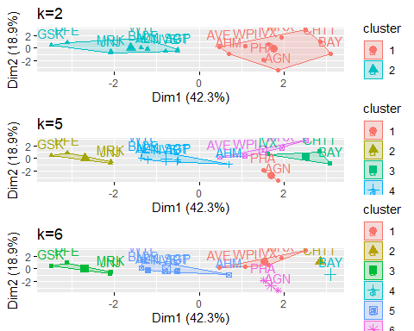

distance<- dist(Pharma_scale, method = "euclidean")  
fviz_dist(distance)

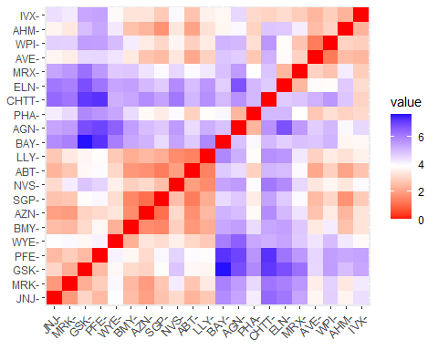

# Estimating the number of clusters  
# Elbow Method is used in scaling the data to determine the value of k  
fviz_nbclust(normal_data, FUNcluster = kmeans, method = "wss") + labs(subtitle = "Elbow Method")

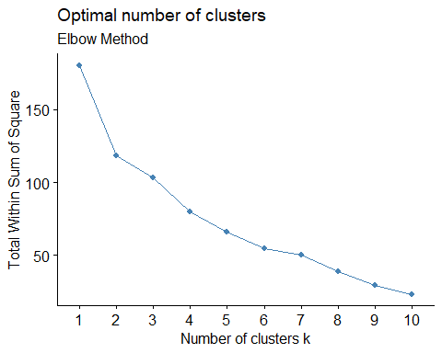

# Silhouette Method is used in scaling the data to determine the number of clusters  
fviz_nbclust(normal_data,FUNcluster = kmeans,method = "silhouette")+labs(subtitle="Silhouette Method")

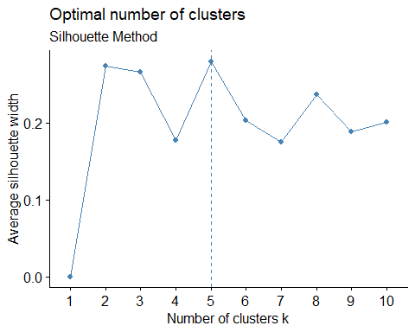

# Final analysis and Extracting results using 5 clusters and Visualize the results  
set.seed(300)  
final_Cluster<- kmeans(Pharma_scale, 5, nstart = 25)  
print(final_Cluster)

## K-means clustering with 5 clusters of sizes 8, 3, 4, 2, 4  
##   
## Cluster means:  
## Market_Cap Beta PE_Ratio ROE ROA Asset_Turnover  
## 1 -0.03142211 -0.4360989 -0.31724852 0.1950459 0.4083915 0.1729746  
## 2 -0.87051511 1.3409869 -0.05284434 -0.6184015 -1.1928478 -0.4612656  
## 3 -0.76022489 0.2796041 -0.47742380 -0.7438022 -0.8107428 -1.2684804  
## 4 -0.43925134 -0.4701800 2.70002464 -0.8349525 -0.9234951 0.2306328  
## 5 1.69558112 -0.1780563 -0.19845823 1.2349879 1.3503431 1.1531640  
## Leverage Rev_Growth Net_Profit_Margin  
## 1 -0.27449312 -0.7041516 0.556954446  
## 2 1.36644699 -0.6912914 -1.320000179  
## 3 0.06308085 1.5180158 -0.006893899  
## 4 -0.14170336 -0.1168459 -1.416514761  
## 5 -0.46807818 0.4671788 0.591242521  
##   
## Clustering vector:  
## ABT AGN AHM AZN AVE BAY BMY CHTT ELN LLY GSK IVX JNJ MRX MRK NVS   
## 1 4 1 1 3 2 1 2 3 1 5 2 5 3 5 1   
## PFE PHA SGP WPI WYE   
## 5 4 1 3 1   
##   
## Within cluster sum of squares by cluster:  
## [1] 21.879320 15.595925 12.791257 2.803505 9.284424  
## (between_SS / total_SS = 65.4 %)  
##   
## Available components:  
##   
## [1] "cluster" "centers" "totss" "withinss" "tot.withinss"  
## [6] "betweenss" "size" "iter" "ifault"

clusplot(Pharma_scale,final_Cluster$cluster, color = TRUE, labels = 2,lines = 0)

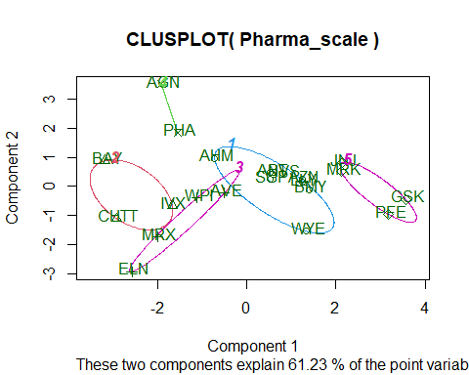

#b) Interpret the clusters with respect to the numerical variables used in forming the clusters.  
  
#Cluster 1 - AHM,SGP,WYE,BMY,AZN, ABT, NVS, LLY ( lowest Market_Cap,lowest Beta,lowest PE_Ratio,highest Leverage,highest Rev_Growth.)  
  
#Cluster 2 - BAY, CHTT, IVX (lowest Rev_Growth,highest Beta and levearge,lowest Net_Profit_Margin)  
  
#Cluster 3 - WPI, MRX,ELN,AVE (lowest PE_Ratio,highest ROE,lowest ROA,lowest Net_Profit_Margin, highest Rev_Growth)  
  
#Cluster 4 - AGN, PHA (lowest Beta,lowest Asset_Turnover, Highest PE Ratio)  
  
#Cluster 5 - JNJ, MRK, PFE,GSK (Highest Market_Cap,ROE, ROA,Asset_Turnover Ratio and lowest Beta/PE Ratio)  
  
Pharma_Cluster <- Pharma[,c(12,13,14)]%>% mutate(clusters = final_Cluster$cluster)%>% arrange(clusters, ascending = TRUE)  
Pharma_Cluster

## Median_Recommendation Location Exchange clusters  
## ABT Moderate Buy US NYSE 1  
## AHM Strong Buy UK NYSE 1  
## AZN Moderate Sell UK NYSE 1  
## BMY Moderate Sell US NYSE 1  
## LLY Hold US NYSE 1  
## NVS Hold SWITZERLAND NYSE 1  
## SGP Hold US NYSE 1  
## WYE Hold US NYSE 1  
## BAY Hold GERMANY NYSE 2  
## CHTT Moderate Buy US NASDAQ 2  
## IVX Hold US AMEX 2  
## AVE Moderate Buy FRANCE NYSE 3  
## ELN Moderate Sell IRELAND NYSE 3  
## MRX Moderate Buy US NYSE 3  
## WPI Moderate Sell US NYSE 3  
## AGN Moderate Buy CANADA NYSE 4  
## PHA Hold US NYSE 4  
## GSK Hold UK NYSE 5  
## JNJ Moderate Buy US NYSE 5  
## MRK Hold US NYSE 5  
## PFE Moderate Buy US NYSE 5

#(c)Is there a pattern in the clusters with respect to the numerical variables (10 to 12)?   
  
plot1<-ggplot(Pharma_Cluster, mapping = aes(factor(clusters), fill=Median_Recommendation))+geom_bar(position = 'dodge')+labs(x ='No of clusters')  
plot2<- ggplot(Pharma_Cluster, mapping = aes(factor(clusters),fill = Location))+geom_bar(position = 'dodge')+labs(x ='No of clusters')  
plot3<- ggplot(Pharma_Cluster, mapping = aes(factor(clusters),fill = Exchange))+geom_bar(position = 'dodge')+labs(x ='No of clusters')  
grid.arrange(plot1, plot2, plot3)

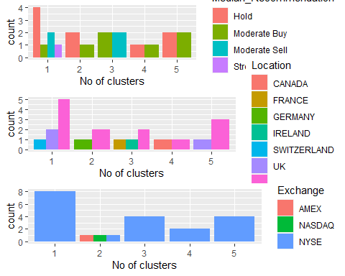

#As per graph:-   
  
#Cluster 1 :The Hold median is the highest in this cluster , which also contains separate Hold, Moderate Buy, Moderate Sell, and Strong Buy medians. They are listed on the NYSE and come from the US, UK, and Switzerland.  
  
#Cluster 2: Although the firms are evenly divided throughout AMEX, NASDAQ, and NYSE, has a distinct Hold and Moderate Buy median, as well as a different count between the US and Germany.  
  
#Cluster 3: listed on the NYSE, has separate counts for France, Ireland, and the US, and has equal moderate buy and sell medians.  
  
#Cluster 4: dispersed throughout the US and UK, as well as being listed in, has the identical hold and moderate buy medians  
  
#Cluster 5: #solely listed on the NYSE, equally dispersed in the US and Canada, with Hold and Moderate Buy medians.  
  
#With respect to media Recommendation Variable ,the clusters follow a particular pattern:  
#Cluster 1 and Cluster 2 has Hold Recommendation.  
#Cluster 3, Cluster 4and Cluster 5 has moderate buy Recommendation.

# (d)Provide an appropriate name for each cluster using any or all of the variables in the dataset.  
  
#Cluster 1 :- HIGH HOLD CLUSTER  
#Cluster 2 :- HOLD CLUSTER  
#Cluster 3 :- BUY-SELL CLUSTER  
#Cluster 4 :- HOLD-BUY CLUSTER  
#Cluster 5 :- HOLD-BUY CLUSTER